Customer satisfaction analysis in travel

The data set used for this project contains customer reviews and feedback retrieved from TripAdvisor. It includes rating and feedback text for various travel and leisure categories, such as Art galleries, Dance clubs , Juice bars , Museums , Resorts , Beaches , Theaters , and Religious Institutions, to analyze overall customer satisfaction.”

Data cleaning
During the data preparation phase, power query was used to clean and transform the data. this included removing duplicates, handling missing values and ensuring correct data types for all columns.” Here verified the data quality across all columns, ensuring there are no missing values or errors in the dataset
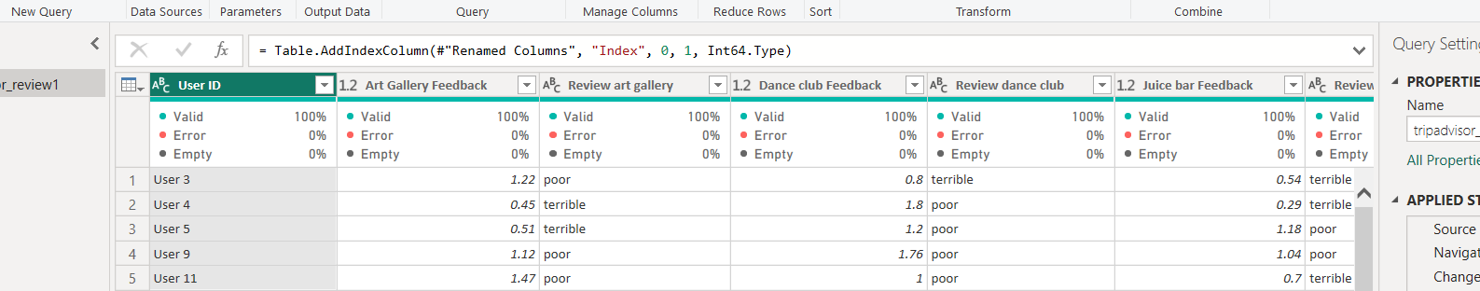

Calculated columns
In this phase, new calculated columns were created to enhance the data model and support the analysis of customer reviews.
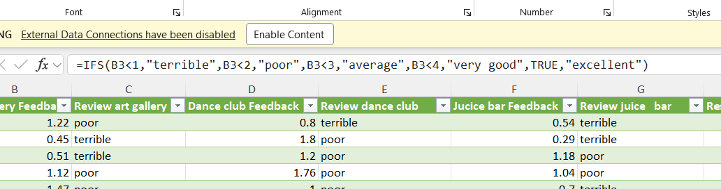the calculated columns were created using the IFS function to categories such as ‘terrible’,’poor’,’average’,’very good’, and ‘excellent’, based on specific numerical thresholds.

Calculated measures
- To calculate the average art gallery feedback, the following measure was created. 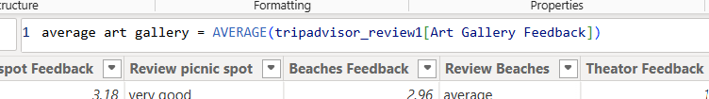
- A measure named average beaches was created using this formula. Its calculates the average of all feedback values from the customers

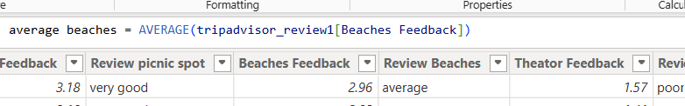
- To calculate the average dance club feedback, the following measure was created. 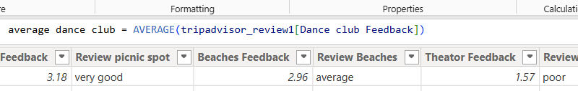
- To calculate the average of juice bar feedback, the following measure was created.
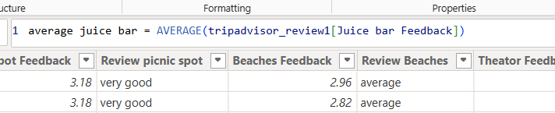
- To calculate the average of museums feedback, the following measure was created.
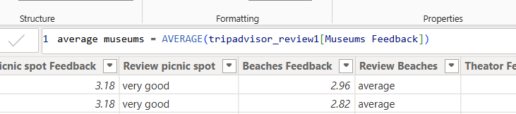
- To calculate the average of picnic spot feedback, the following measure was created.
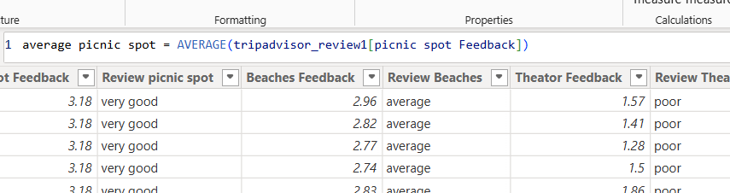
- To calculate the average of religious institute feedback, the following measure was created

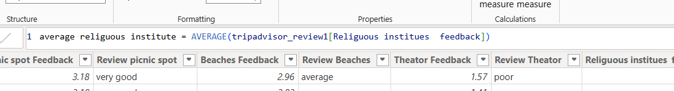
8. To calculate the average of restaurant feedback, the following measure was created
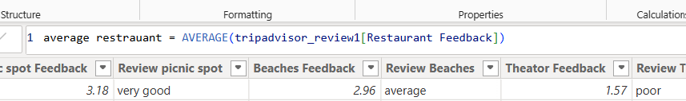
9. . To calculate the average of theater feedback, the following measure was created
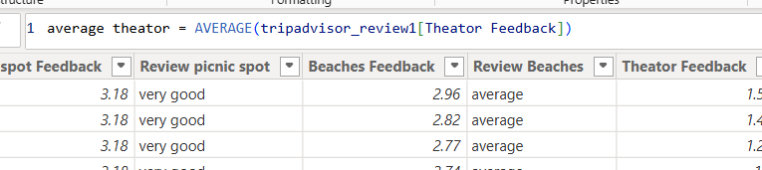

10. . To calculate the average of resort feedback, the following measure was created
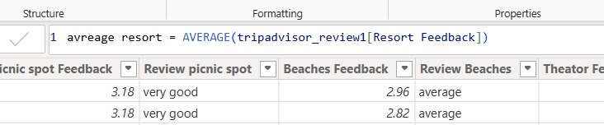
11. A measure named Total reviews was created using this formula. It calculates the average of all feedback values from the customers
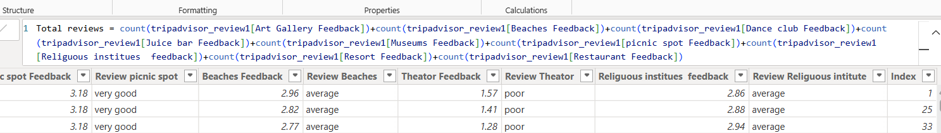

Data visualization
- 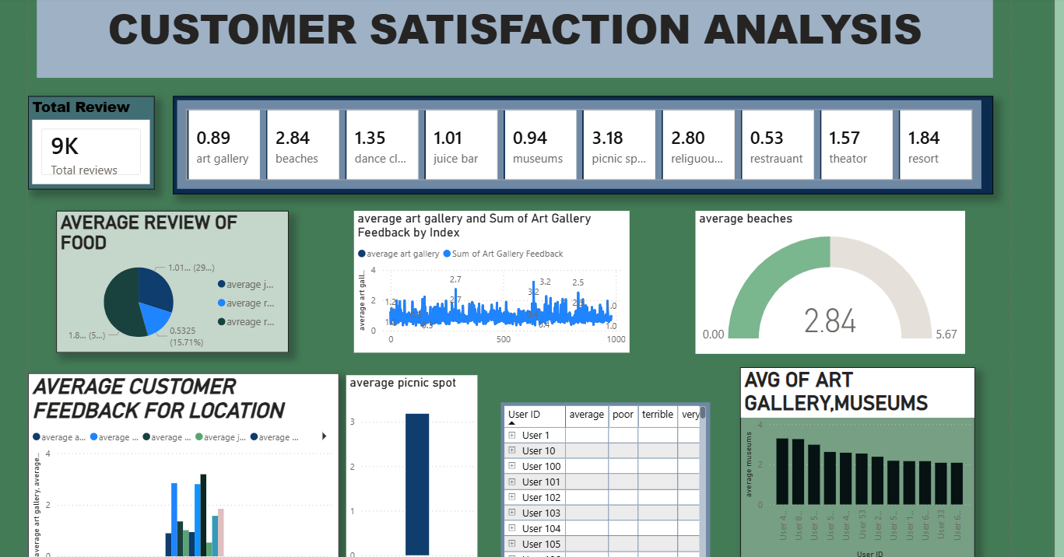A ‘card’ visualization has been utilized to display the total number of reviews this summarized count of 9k,providing an immediate overview of the total review volume analyzed in the dashboard.
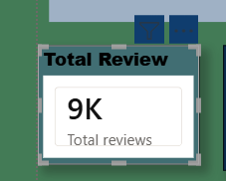

2.The cards at the top of the dashboard display the average customer satisfaction ratings for different locations and services, such as art gallery ,beaches, and restaurants etc.,

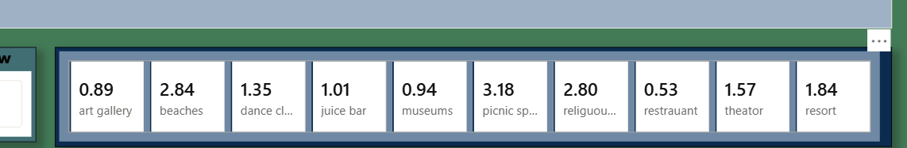
3.pie chart used to compare the food based places such juice Bar and restaurant.
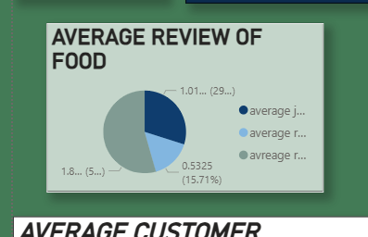
4.average beaches gauge chart is used to show average satisfaction score current value 2.84
Measurement rang :0.00 to5.65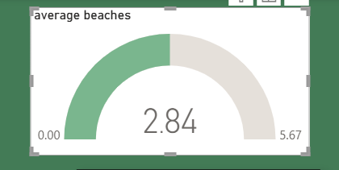
5. here I used clustered column chart to analyses the picnic spot, as per customers review picnic spot got “very good”
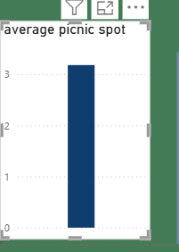
6.Here clustered column chart is to check average of art gallery and museum review by customer. According to user id
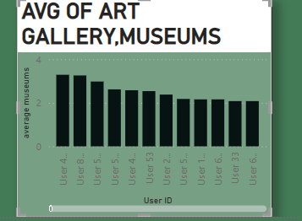
7.this line chart is used to compare average and sum value of art gallery feedback by customers

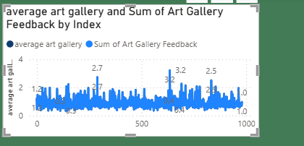
8.This bar chart represents the feedback levels for each distinct area ,allowing you to see at a glance which places are meeting expectations.
This insights helps in making data driven decisions to allocate resources here we have improve the services in
- RESTRAUNT
- ART GALLERY
- MUSEUMS
- 